A Vocational Training Report On

**LIBRARY MANAGEMENT SYSTEM**

Submitted to

**CHHATTISGARH SWAMI VIVEKANAND TECHNICAL UNIVERSITY, BHILAI**

*In partial fulfillment*

*For the award of the degree of*

**Bachelor of Engineering**

In

**Computer Science and Engineering**

By

**Himank Tiwari,**

**Jyoti Yadav**

**Under the Guidance of**

**Prof. Ajay Kushwaha**

C:\Documents and Settings\manoj kumar\My Documents\Logo RCET\rungta institution.png

**Department of Computer Science and Engineering**

**Rungta College of Engineering and Technology,**

**Kohka – Kurud Road, Bhilai, Chhattisgarh 490021**

**Session: 2020– 2021**

**DECLARATION BY THE CANDIDATE**

I the undersigned solemnly declare that the report of the project work entitled “**Library Management System”**, is based on my own work carried out during the course of my study under the supervision ofProf. Ajay kushwaha.

I assert that the statements made and conclusions drawn are an outcome of the project work. I further declare that to the best of my knowledge and belief that the report does not contain any part of any work which has been submitted for the award of any other degree/diploma/certificate in this University/ any other University of India or any other country.

**_________________**

Himank Tiwari

Roll no. 301302217047

Enrollment no. BD3457

Jyoti Yadav

Roll No. 301302217050

Enrollment No. BD4292

**CERTIFICATE**

This is to Certify that the report of the project submitted is an outcome of the project work entitled **Library Management System** carried out by **Himank Tiwari** bearing **Roll No. 301302217047, Enrollment No. BD3457** and **Jyoti Yadav** bearing **Roll No. 301302217050, Enrollment No. BD4292** under my guidance and supervision for the award of Degree in Bachelor of Engineering in Computer Science & Engineering from Chhattisgarh Swami Vivekananda Technical University, Bhilai (C.G).

To the best of my knowledge the report

1. Embodies the work of the candidate himself / herself,
2. Has duly been completed,
3. Fulfills the requirement of the Ordinance relating to the BE degree of the University,
4. Is up to the desired standard for the purpose of which is submitted.

**Guide**

**Prof. Ajay Kushwaha**

**Department of Computer Sc. & Engg.**

The project work as mentioned above is hereby being recommended and forwarded for examination and evaluation.

**(Prof. K. J. Satao)**

**Head of the Department**

**Department of Computer Sc. & Engg.**

**CERTIFICATE BY THE EXAMINERS**

This is to Certify that the project the entitled

**” LIBRARY MANAGEMENT SYSTEM”**

Submitted by

Himank Tiwari  **Enrollment No**: BD3457  **Roll No:** 301302217018

Jyoti Yadav **Enrollment No**: BD4292 **Roll No:** 301302217050

Have been examined by the undersigned as a part of the examination for the award of Bachelor of Engineering degree in Computer Science and Engineering from Chhattisgarh Swami Vivekanand Technical University, Bhilai (C.G.).

**(Internal Examiner) (External Examiner) Name: Name:**

**Date: Date:**

**ACKNOWLEDGEMENT**

I have great pleasure in the submission of this project report entitled “**Library Management System”** in partial fulfillment the degree of Bachelor of Engineering (CSE). While submitting this Project report, I take this opportunity to thank those directly or indirectly related to project work.

I would like to thank my guide **Prof. Ajay Kushwaha** who has provided the opportunity and organizing project for me. Without her active cooperation and guidance, it would have become very difficult to complete task in time.

I would like to express sincere thanks and gratitude to, Prof. K. J. Satao, **Head of the Department** Computer Science & Engineering for their encouragement and cordial support.

I am also highly grateful to Mr. Santosh Rungta sir, Chairman, Dr. Sourabh Rungta, Director Technical, Mr. Sonal Rungta, Director F & A, Dr. Mohan Awasthi, Principal RCET, Bhilai and Mr. S.B Burje, Vice Principal RCET, Bhilai. For their kind support and permission to use the facilities available in the institute.

**Himank Tiwari**

**Roll No:** 301302217047

**Enrollment No. BD3457**

**Jyoti Yadav**

**Roll No**. 301302217050

**Enrollment No. BD4292**

**INDEX.**

* ABSTRACT
* INTRODUCTION

-> HARDWARE AND SOFTWARE SPECIFICATION

-> INTRODUCTION TO LIBRARY MANAGEMENT SYSTEM

* CODING AND IMPLEMENTATION
* RESULT/OUTPUT
* ADVANTAGES AND DISADVANTAGES
* ER DIAGRAM, USE-CASE
* REQUIRMENT AND CHALLENGES
* CONCLUSION

**ABSTRACT:**

The Library Management System is an application for assisting a librarian in managing a book library in a university. The system would provide basic set of features to add/update members, add/update books, and manage check in specifications for the systems based on the client’s statement of need.

Library management system is a typical management Information system (MIS), its Development include the establishment and maintenance of back-end database and front-end application development aspects. For the former require the establishment of data consistency and integrity of the strong data security and good libraries. As for the latter requires the application fully functional, easy to use and so on.

1. ***INTRODUCTION***

# 1.1 Hardware Specification

CPU: 2*64 bit 2.8GHz 8.00 GT/s CPUs

RAM: Min 2 GB

Storage: Max. 10 GB

Internet access to download the files from Anaconda Cloud or a USB drive containing all of the files you need with alternate instruction for air gapped installation.

1.2 Technology Used:

Backend**:**

Mysql/Sqlite Database.

Frontend**:**

VSCode, Python 3.1(Tkinter)

.

1.3 INTRODUCTION TO LIBRARY MANAGEMENT

The project titled Library Management System is Library

Management software for monitoring and controlling the transactions in a library .The project “Library Management System” is developed in php, which mainly focuses on basic operations in a library like adding new books, and updating new information, searching books and members and return books.

This project of “LIBRARY MANAGEMENT SYSTEM” of gives us the complete information about the library. We can enter the record of new books and retrieve the details of books available in the library. We can issue the books to the students and maintain their records and can also check how many books are issued and stock available in the library. In this project we can maintain the late fine of students who returns the issued books after the due date.

Throughout the project the focus has been on presenting information and comments in an easy and intelligible manner. The project is very useful for those who want to know about Library Management System.

**2. *CODING AND IMPLEMENTATION:***

from tkinter import *

from tkinter import colorchooser

from tkinter import ttk

from PIL import Image,ImageTk

import sqlite3

from tkinter import messagebox

cn=sqlite3.connect("Library.db")

cur=cn.cursor()

global r

r=Tk()

#r.attributes('-fullscreen',True)

r.title("Library Management System")

r.geometry('1080x1920')

###########ADDING BOOKS#################

def AB():

    window= Toplevel(r)

    window.title("ADD BOOKS")

    window.geometry('1600x1080')

    ai=PhotoImage(file="/sdcard/Project/pictures/gb.png")

    head=Label(window,height=50,width=900,text="ADD BOOKS",image=ai,bg='red',compound=LEFT,font=("Times New Roman", 12, "bold"))

    head.pack(pady=(40,30))

    af=Frame(window,height=1000,bg='lightpink')

    af.pack(fill=X,padx=20)

    al1=Label(af,text='BOOK NAME:',font=("Times New Roman", 7))

    al1.place(x=180,y=70)

    al2=Label(af,text='AUTHOR:',font=("Times New Roman", 7))

    al2.place(x=180,y=210)

    al3=Label(af,text='PAGE:',font=("Times New Roman", 7))

    al3.place(x=180,y=350)

    al4=Label(af,text='LANGUAGE:',font=("Times New Roman", 7))

    al4.place(x=180,y=500)

    global ae1

    ae1=Entry(af,width=25)

    ae1.place(x=550,y=70)

    ae1.insert(0, "   Enter book name")

    global ae2

    ae2=Entry(af,width=25)

    ae2.place(x=550,y=210)

    ae2.insert(0, "   Enter author's name")

    global ae3

    ae3=Entry(af,width=25)

    ae3.place(x=550,y=350)

    ae3.insert(0, "   Enter pages")

    global ae4

    ae4=Entry(af,width=25)

    ae4.place(x=550,y=500)

    ae4.insert(0, "   Enter language")

    ab=Button(af,text='Submit',command=addbook,height=20,width=30)

    ab.place(x=700,y=640)

    window.mainloop()

###########################################

#########ADD BOOKS TO DB#################

def addbook():

    n=ae1.get()

    a=ae2.get()

    s=ae3.get()

    l=ae4.get()

    if n and a and s and l !="":

        query="insert into 'books'(book_name,book_auth,book_page,book_lang) VALUES(?,?,?,?)"

        cur.execute(query,(n,a,s,l))

        cn.commit()

        messagebox.showinfo('Success','Inserted Successfully')

    else:

            messagebox.showinfo('Error','Check ur code')

    displaybook()

    STATS()

#########################################

############ADDING MEMBERS#############

def AM():

    window1=Toplevel(r)

    window1.title("ADD which MEMBER")

    window1.geometry('1400x745')

    window1.attributes('-fullscreen',False)

    ui=PhotoImage(file="/sdcard/Project/pictures/au.png")

    uhead=Label(window1,height=90,width=600,text="ADD MEMBER",image=ui,bg='cyan',compound=LEFT,font=("Times New Roman", 12, "bold"))

    uhead.pack(pady=(40,30))

    uf=Frame(window1,height=1000,bg='lightpink')

    uf.pack(fill=X,padx=20)

    ul1=Label(uf,text='NAME:',font=("Times New Roman", 7))

    ul1.place(x=180,y=100)

    ul2=Label(uf,text='CONTACT NO.:',font=("Times New Roman", 7))

    ul2.place(x=180,y=240)

    global ue1

    ue1=Entry(uf,width=25)

    ue1.place(x=550,y=100)

    ue1.insert(0, "   Enter user name")

    global ue2

    ue2=Entry(uf,width=25)

    ue2.place(x=550,y=240)

    ue2.insert(0, "   Enter Phone no.")

    ub=Button(uf,text='Submit',command=addmember)

    ub.place(x=600,y=370)

    window1.mainloop()

#########################################

#########ADD MEMBERS TO DB#############

def addmember():

    nm=ue1.get()

    ph=ue2.get()

    if nm and ph!="":

        query="insert into 'members'(member_name,member_phone) VALUES(?,?)"

        cur.execute(query,(nm,ph))

        cn.commit()

        messagebox.showinfo('Success','Added  Successfully')

    else:

            messagebox.showinfo('Error','Check ur Input')

#########################################

###########GIVING BOOKS(event)###########

def GB1(e):

    query="select * from books where book_id=?"

    bl=cur.execute(query,(id,)).fetchall()

    print(bl[0][5])

    if (bl[0][5]==0):

        window2=Toplevel(r)

        window2.title("GIVE BOOK")

        window2.geometry('1400x745')

        window2.attributes('-fullscreen',False)

        gi=PhotoImage(file="/sdcard/Project/pictures/ab.png")

        ghead=Label(window2,height=90,width=600,text="ISSUE BOOKS",image=gi,bg='cyan',compound=LEFT,font=("Times New Roman", 12, "bold"))

        ghead.pack(pady=(40,30))

        gf=Frame(window2,height=1000,bg='lightpink')

        gf.pack(fill=X,padx=20)

        gl1=Label(gf,text='BOOK NAME:',font=("Times New Roman", 7))

        gl1.place(x=180,y=100)

        gl2=Label(gf,text='MEMBER NAME:',font=("Times New Roman", 7))

        gl2.place(x=180,y=240)

        query1=cur.execute("select * from books").fetchall()

        booklist=[]

        for b in query1:

            booklist.append(str(b[0])+'-'+str(b[1]))

        print(booklist)

        global bookbox

        bookbox=ttk.Combobox(gf)

        bookbox['value']=booklist

        val1=lb1.get(lb1.curselection())

        vid=val1.split("-")[0]

        print(vid)

        bookbox.current(int(vid)-1)

        bookbox.place(x=550,y=100)

        query2=cur.execute("select * from members").fetchall()

        memlist=[]

        for m in query2:

            memlist.append(str(m[0])+'-'+str(m[1]))

        print(memlist)

        global membox

        membox=ttk.Combobox(gf)

        membox['value']=memlist

        membox.place(x=550,y=240)

        gb=Button(gf,text='Submit yo yo',command=issuebook1)

        gb.place(x=600,y=370)

        window2.mainloop()

    elif(bl[0][5]==1):

        messagebox.showinfo("Error",'Book Unavailable')

#########################################

#########ISSUE BOOKS(DB(event))###########

def issuebook1():

    name=bookbox.get()

    member=membox.get()

    if name and member!=0:

        query="insert into borrow(bbook_id,bmem_id) values(?,?)"

        cur.execute(query,(name,member))

        cn.commit()

        messagebox.showinfo("Success","Book Issued")

        cur.execute("update books set book_status=? where book_id =?",(1,id))

        cn.commit()

    else:

        messagebox.showinfo("Failed!","Check Your Input")

    displaybook()

    STATS()

#########################################

###########GIVING BOOK(btn)##############

def GB2():

    window3=Toplevel(r)

    window3.title("GIVE BOOK")

    window3.geometry('1400x745')

    gi=PhotoImage(file="/sdcard/Project/pictures/au.png")

    ghead=Label(window3,height=90,width=600,text="ISSUE BOOKS",image=gi,bg='cyan',compound=LEFT,font=("Times New Roman", 12, "bold"))

    ghead.pack(pady=(40,30))

    gf=Frame(window3,height=1000,bg='lightpink')

    gf.pack(fill=X,padx=20)

    gl1=Label(gf,text='BOOK NAME:',font=("Times New Roman", 7))

    gl1.place(x=180,y=100)

    gl2=Label(gf,text='MEMBER NAME:',font=("Times New Roman", 7))

    gl2.place(x=180,y=240)

    query1=cur.execute("select * from books where book_status=0").fetchall()

    booklist=[]

    for b in query1:

        booklist.append(str(b[0])+'-'+str(b[1]))

    print(booklist)

    global bookbox1

    bookbox1=ttk.Combobox(gf)

    bookbox1['value']=booklist

    bookbox1.place(x=550,y=100)

    query2=cur.execute("select * from members").fetchall()

    memlist=[]

    for m in query2:

        memlist.append(str(m[0])+'-'+str(m[1]))

    print(memlist)

    global membox1

    membox1=ttk.Combobox(gf)

    membox1['value']=memlist

    membox1.place(x=550,y=240)

    gb=Button(gf,text='Submit',command=issuebook2)

    gb.place(x=600,y=370)

    window3.mainloop()

#########################################

##########ISSUE BOOKS(DB(btn))###########

def issuebook2():

    name=bookbox1.get()

    member=membox1.get()

    print(name)

    id1=name.split("-")[0]

    print(id1)

    if name and member!=0:

        query="insert into borrow(bbook_id,bmem_id) values(?,?)"

        cur.execute(query,(name,member))

        cn.commit()

        messagebox.showinfo("Success","Book Issued")

        cur.execute("update books set book_status=? where book_id =?",(1,id1))

        cn.commit()

    else:

        messagebox.showinfo("Failed!","Check Your Input")

    displaybook()

    STATS()

#########################################

##########RETURN BOOK(window)###########

def RB():

    window4=Toplevel(r)

    window4.title("GIVE BOOK")

    window4.geometry('1400x745')

    window4.attributes('-fullscreen',False)

    ri=PhotoImage(file="/sdcard/Project/pictures/rb.png")

    rhead=Label(window4,height=90,width=600,text=" RETURN BOOKS ",image=ri,bg='cyan',compound=LEFT,font=("Times New Roman", 12, "bold"))

    rhead.pack(pady=(40,30))

    rf=Frame(window4,height=1000,bg='lightpink')

    rf.pack(fill=X,padx=20)

    rl1=Label(rf,text='BOOK NAME:',font=("Times New Roman", 7))

    rl1.place(x=180,y=100)

    rl2=Label(rf,text='MEMBER NAME:',font=("Times New Roman", 7))

    rl2.place(x=180,y=240)

    query1=cur.execute("select * from books where book_status=1").fetchall()

    booklist=[]

    for b in query1:

        booklist.append(str(b[0])+'-'+str(b[1]))

    print(booklist)

    global bid

    global bookbox2

    bookbox2=ttk.Combobox(rf)

    bookbox2['value']=booklist

    bookbox2.place(x=550,y=100)

    def find(event):

        bid=bookbox2.get()

        print(bid)

        query2="select bmem_id from borrow where bbook_id=?"

        memb=cur.execute(query2,(bid,)).fetchall()

        global membox2

        memlist=[]

        memlist.append(memb[0][0])

        membox2=ttk.Combobox(rf)

        membox2['value']=memlist

        membox2.current(0)

        membox2.place(x=550,y=240)

    rb=Button(rf,text='Return',command=Return,width=10)

    rb.place(x=650,y=370)

    bookbox2.bind("<<ComboboxSelected>>", find)

    window4.mainloop()

#########################################

#############RETURN BOOK(DB)############

def Return():

    bk=bookbox2.get()

    mem=membox2.get()

    print(bk)

    id2=bk.split("-")[0]

    print(id2)

    if bk and mem!=0:

        query="delete from borrow where bbook_id=? "

        cur.execute(query,(bk,))

        cn.commit()

        cur.execute("update books set book_status=? where book_id =?",(0,id2))

        cn.commit()

        messagebox.showinfo("Success","Book Returned")

    else:

        messagebox.showinfo("Failed!","Check Your Input")

    displaybook()

    STATS()

#########################################

#############DISPLAYING BOOKS##########

def displaybook():

    lb1.delete(0,'end')

    lb2.delete(0,'end')

    query='select * from books'

    count=0

    books= cur.execute(query).fetchall()

    for i in books:

        lb1.insert(count,str(i[0])+ '-'+str(i[1]))

        count+=1

##########################################

##########BOOK INFORMATION###########

def bookinfo(event):

    lb2.delete(0,'end')

    value=lb1.get(lb1.curselection())

    print(value)

    global id

    id=value.split("-")[0]

    print(id)

    query="select * from books where book_id=?"

    booklist=cur.execute(query,(id,)).fetchall()

    for b in booklist:

        lb2.insert(0, "Book Name : " +str(b[1]))

        lb2.insert(1, "Author : " +str(b[2]))

        lb2.insert(2, "Page : " +str(b[3]))

        lb2.insert(3, "Language : " +str(b[4]))

        if (b[5]==0):

            lb2.insert(4,"Status : Available")

        else:

            lb2.insert(4,"Status : Unavailable")

########################################

f=Frame(r,height=50,width=100,bg="lightblue",relief=SUNKEN,bd=5)

f.place(x=5,y=5)

i1=PhotoImage(file="D:/Work/Vscode/gb.png")

i2=PhotoImage(file="D:/Work/Vscode/ab.png")

i3=PhotoImage(file="D:/Work/Vscode/au.png")

i4=PhotoImage(file="D:/Work/Vscode/clr.png")

s=PhotoImage(file="D:/Work/Vscode/s.png")

b1=Button(f,text="GIVE BOOK",bd=5,relief=RAISED,image=i1,compound=LEFT,command=GB2)

b2=Button(f,text="ADD BOOK",bd=5,relief=RAISED,image=i2,compound=LEFT,command=AB)

b3=Button(f,text="ADD MEMBER",bd=5,relief=RAISED,image=i3,compound=LEFT,command=AM)

b4=Button(f,text="RETURN ",bd=5,image=i4,compound=LEFT,relief=RAISED,command=RB)

b1.pack(side=LEFT,pady=10,padx=3)

b2.pack(side=LEFT,pady=10,padx=3)

b3.pack(side=LEFT,padx=3)

b4.pack(side=LEFT,padx=(3,50),pady=10)

cf=LabelFrame(r,width=1440,height=815,bg="lightpink",bd=5)

cf.place(x=11,y=160)

tab=ttk.Notebook(cf)

lbm=Frame(tab)

stat=Frame(tab)

tab.add(lbm,text="Library")

tab.add(stat,text='Statistics')

tab.pack()

lb1=Listbox(lbm,width=24,height=13,bd=7,relief=SUNKEN,bg='#ffdde2',exportselection=False)

lb1.pack(side=LEFT)

sb=Scrollbar(lbm,orient=VERTICAL,command=lb1.yview)

sb.pack(side=LEFT,fill=Y)

lb1.config(yscrollcommand=sb.set)

lb2=Listbox(lbm,width=28,height=13,bd=7,relief=SUNKEN)

lb2.pack(side=LEFT)

l=LabelFrame(r,text="Search Box",bg="lightyellow",height=900,width=400,bd=10,relief=RAISED)

l.place(x=1460,y=150)

e1=Entry(l,bd=4,relief=SUNKEN,width=13)

e1.place(x=8,y=8)

############SEARCHING BOOKS#############

def search():

    lb1.delete(0,'end')

    lb2.delete(0,'end')

    count=0

    svalue=e1.get()

    query='select * from books where book_name like ?'

    sbooks=cur.execute(query,('%'+svalue+'%',)).fetchall()

    for s in sbooks:

        lb1.insert(count,str(s[0])+'-'+str(s[1]))

        count+=1

    e1.delete(0,'end')

##########################################

sb=Button(l,image=s,command=search)

sb.place(x=364,y=3)

l1=LabelFrame(l,text="Sort By:",bg="lightgreen",height=300,width=430)

l1.pack(side=LEFT,padx=3,pady=(83,3))

##############LISTING BOOKS###############

def listbook():

    sbook=one.get()

    query='select * from books where book_status=?'

    count=0

    if sbook==1:

        displaybook()

    elif sbook==2:

        lb1.delete(0,'end')

        lb2.delete(0,'end')

        library=cur.execute(query,(0,)).fetchall()

        for l in library:

            lb1.insert(count,str(l[0])+'-'+str(l[1]))

            count+=1

    else:

        lb1.delete(0,'end')

        borr=cur.execute(query,(1,)).fetchall()

        for b in borr:

            lb1.insert(count,str(b[0])+'-'+str(b[1]))

            count+=1

##########################################

###############STATISTICS#################

bkcount=Label(stat,text='ALL BOOKS COUNT:')

bkcount.place(x=200,y=170)

lcount=Label(stat,text='ALL LIBRARY COUNT:')

lcount.place(x=200,y=260)

brcount=Label(stat,text='ALL BORROWED COUNT:')

brcount.place(x=200,y=350)

def STATS():

    bk=cur.execute("select count(book_id) from books").fetchall()

    lib=cur.execute("select count(book_id) from books where book_status = 0").fetchall()

    brr=cur.execute("select count(book_id) from books where book_status = 1").fetchall()

    print(bk[0][0])

    print(lib[0][0])

    print(brr[0][0])

    bkcount.config(text='ALL BOOKS COUNT : '+str(bk[0][0]))

    lcount.config(text='ALL LIBRARY COUNT : '+str(lib[0][0]))

    brcount.config(text='ALL BORROWED COUNT : '+str(brr[0][0]))

STATS()

#########################################

one=IntVar()

r1=Radiobutton(l1,text="All Books",bg="lightgreen",var=one,value=1)

r2=Radiobutton(l1,text="In Library",bg="lightgreen",var=one,value=2)

r3=Radiobutton(l1,text="Borrowed",bg="lightgreen",var=one,value=3)

r1.place(y=11)

r2.place(y=69)

r3.place(y=130)

sort=Button(l1,text="sort",command=listbook)

sort.pack(pady=(200,5))

img=ImageTk.PhotoImage(Image.open("D:/Work/Vscode/lib.jpg"))

ll=Label(l1,height=300,width=430,text='मोर लाइब्रेरी',image=img,compound=BOTTOM)

ll.pack(pady=(20,5))

lb1.bind('<Double-Button-1>',GB1)

lb1.bind('<<ListboxSelect>>',bookinfo)

displaybook()

r.mainloop()

**3. *RESULT/OUTPUT:***

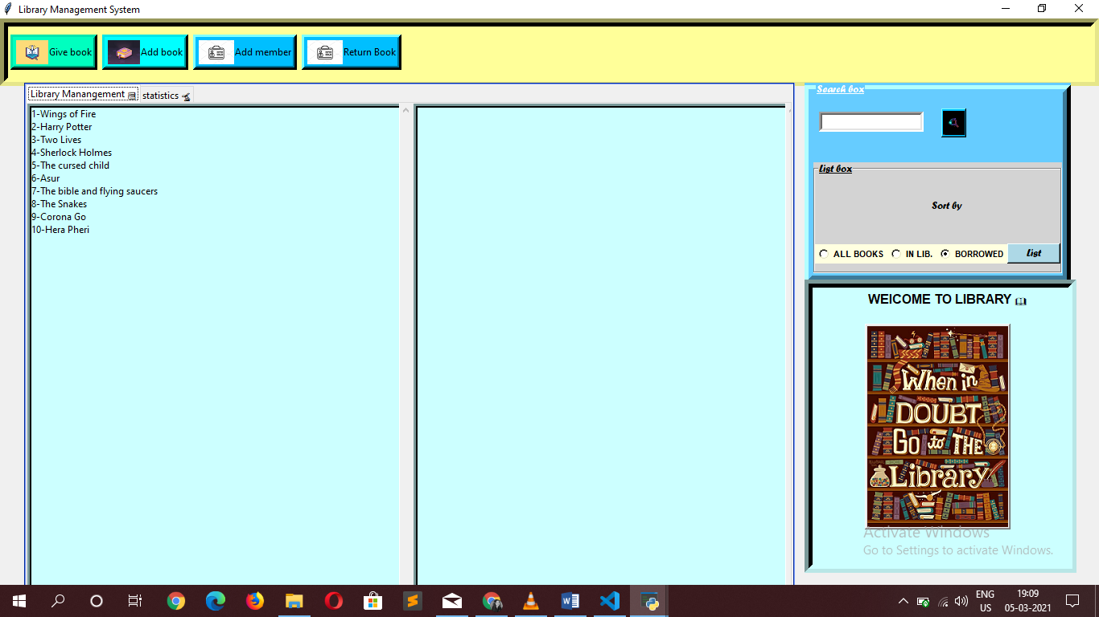

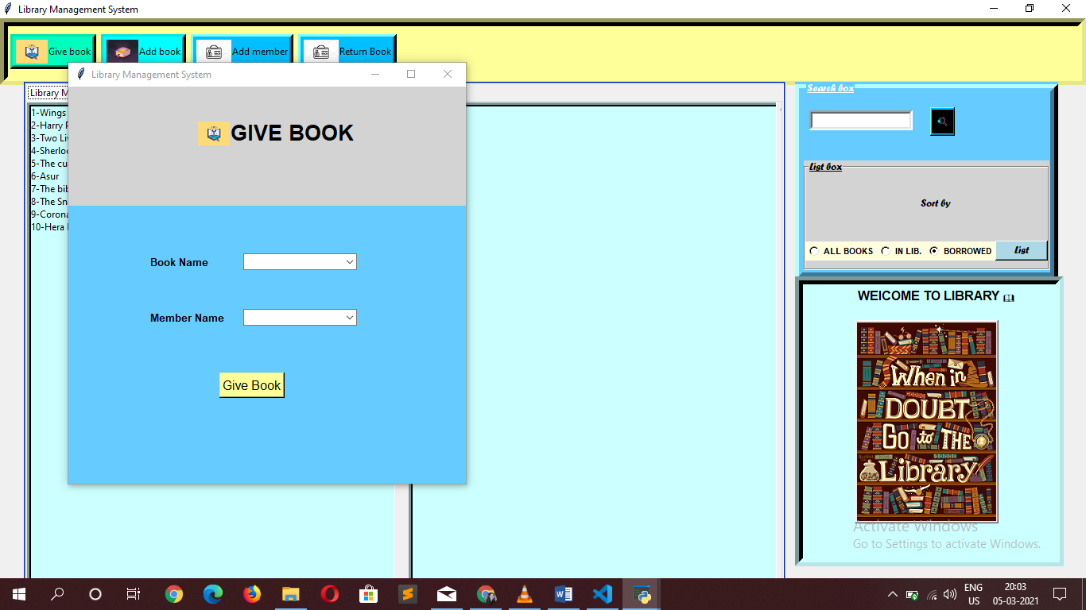

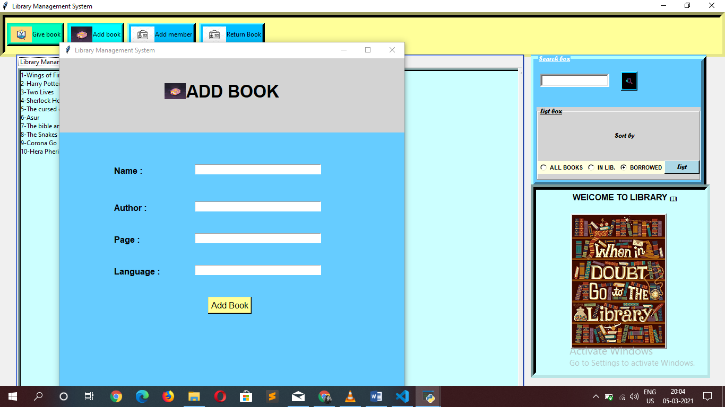

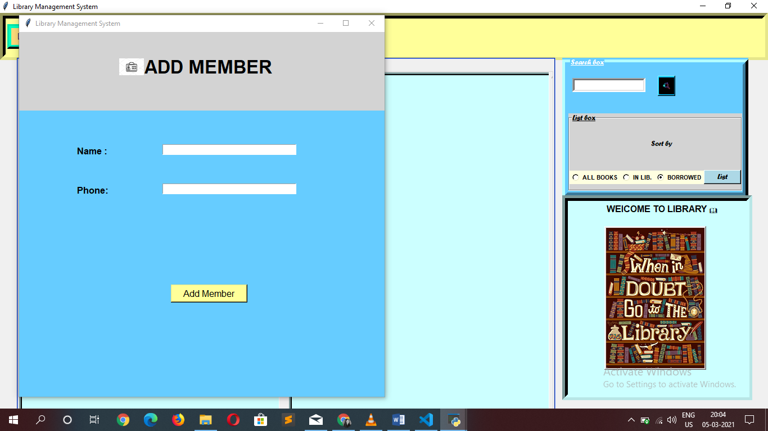

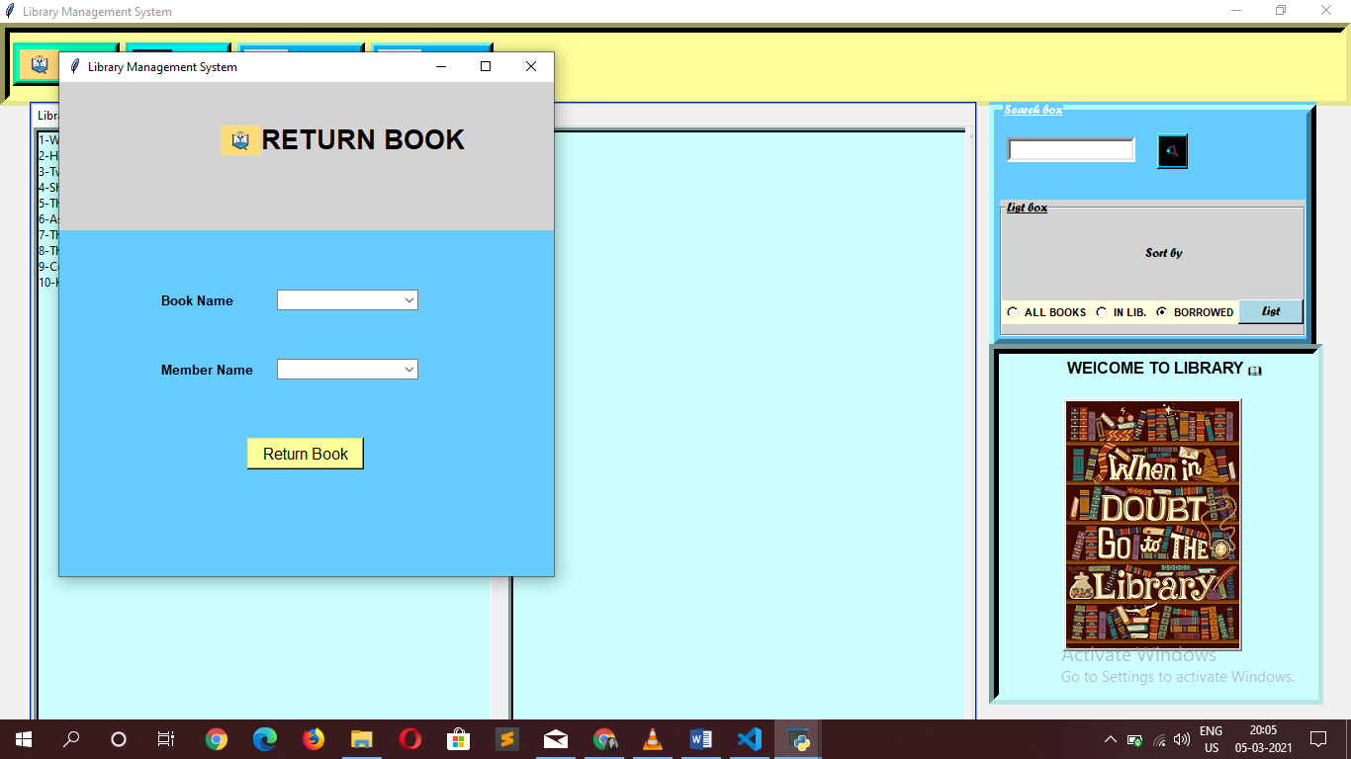

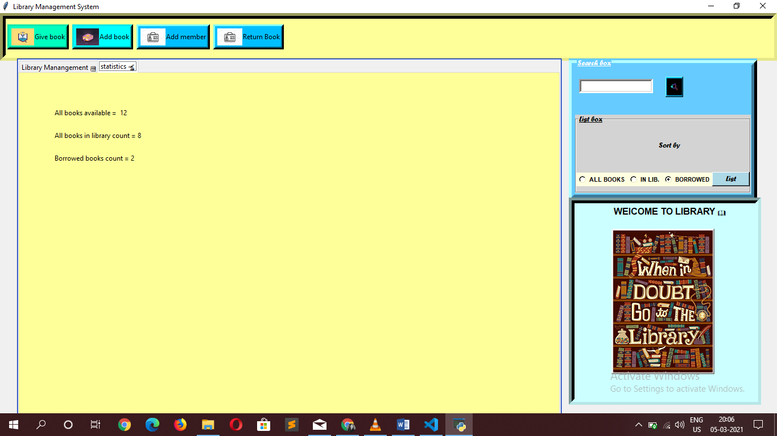

**4*. ER DIAGRAM*:**

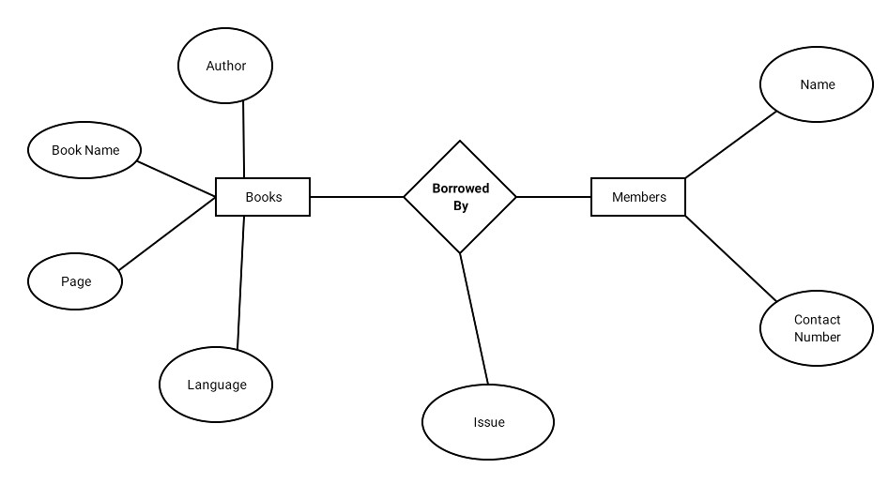

**USE-CASE:**

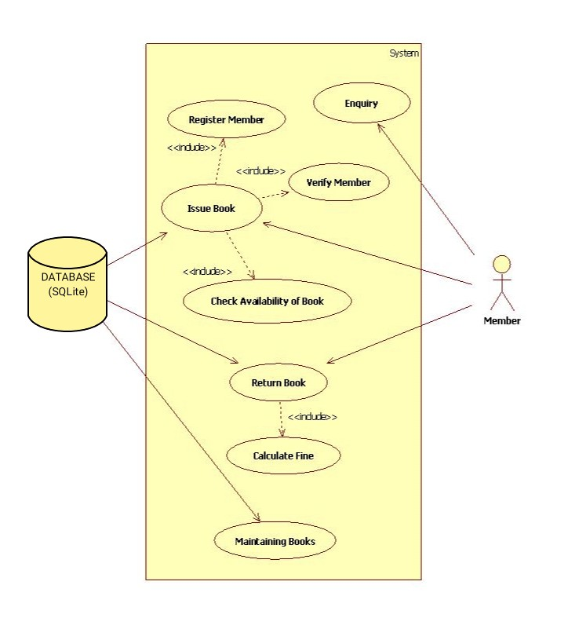

**5. *ADVANTAGES*:**

* Simple and easy to operate
* Increase librarian’s efficiencies
* Mobile access, anytime, anywhere
* Search, add, update, and view library materials online
* Helps to manage library functions constructively
* Saves time and reduces overheads
* Reduce library’s operating cost
* Customized reports for better management
* Remove manual processes to issue books and maintain records

**6. *DISADVANTAGES*:**

* Stored data is predisposed to data loss because of Sqlite database.
* Sometimes it is complicated to operate for first-time users
* Requires high-speed internet connectivity for a web-based system
* Risk of computer virus
* Open source system stocks data on the computer’s hard drive. This raises the risk of data loss.

**7. REQUIREMENTS AND CHALLENGES:**

**7.1 External Interface Requirements:**

It should be simple and easy for consumers to understand and use. It should be an immersive interface. For the user and administrator, the device should prompt the login to the program and correct feedback parameters.

**7.2 Performance Requirements:**

The computer’s capability depends on the software’s efficiency. Provided the database size is big enough, the program will take any number of inputs. This would be dependent on the memory space available.

**7.3 Challenges:**

The computer viruses, lack of standardization for digitized information, quick degrading properties of digitized material, different display standard of digital product and its associated problem, health hazard nature of the radiation from monitor etc. makes digital libraries at times handicap.

1. Copyright: - Digitization violates the copy right law as the thought content of one author can be freely transfer by other without his acknowledgement. So One difficulty to overcome for digital libraries is the way to distribute information.
2. Limit of access: - Lack of Internet connectivity makes it limited to the use only by certain people.

**8. CONCLUSION:**

* This project of Library Management System is for computerizing the working in the library.
* The software takes care of all requirements of a library and is capable of provide easy and effective storage of information related to books, members and users.
* It allows to store the book details, members details in a library.
* The system is strong enough to withstand regressive yearly operations under conditions where the database is maintained and cleared over a certain period of span.
* The implementation of the system in the organization will considerably reduce data entry, time and also provide readily calculated reports and status of a library.
* It is easy to use and implement.
* The system contains each separate section and maintenance of the books as well as the members.
* It provides the complete status of the all the books in the library also with the available books and the borrowed books.
* The database is maintained without any hustle which means you can see the data or status whenever you want and even can also retrieve the old data as well.
* Since the data is being stored properly, information about the members even oldest one can also be retrieved without any trouble.
* GUI makes it more user friendly and interface is easy to access.